Create the ALB VPC
Topic: VPC network foundation
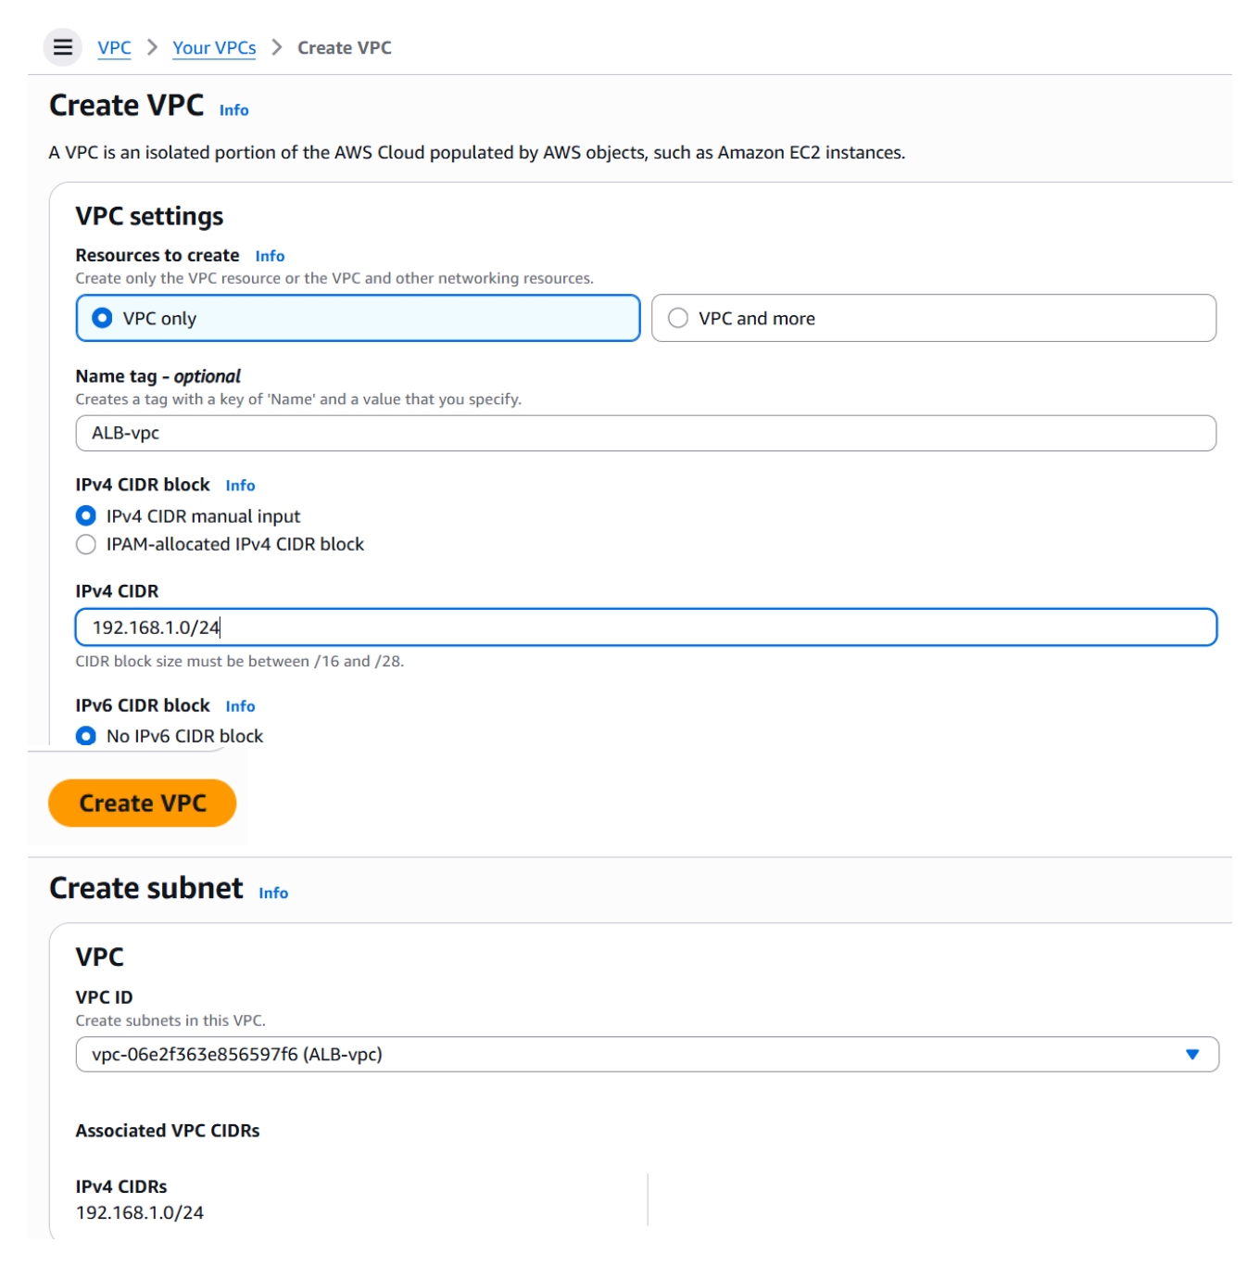
Action: Created the VPC for the load-balancer setup and configured its VPC CIDR block, then moved on to creating the required subnets inside the VPC.

Configure Public Subnets
Topic: Subnet configuration for the ALB VPC
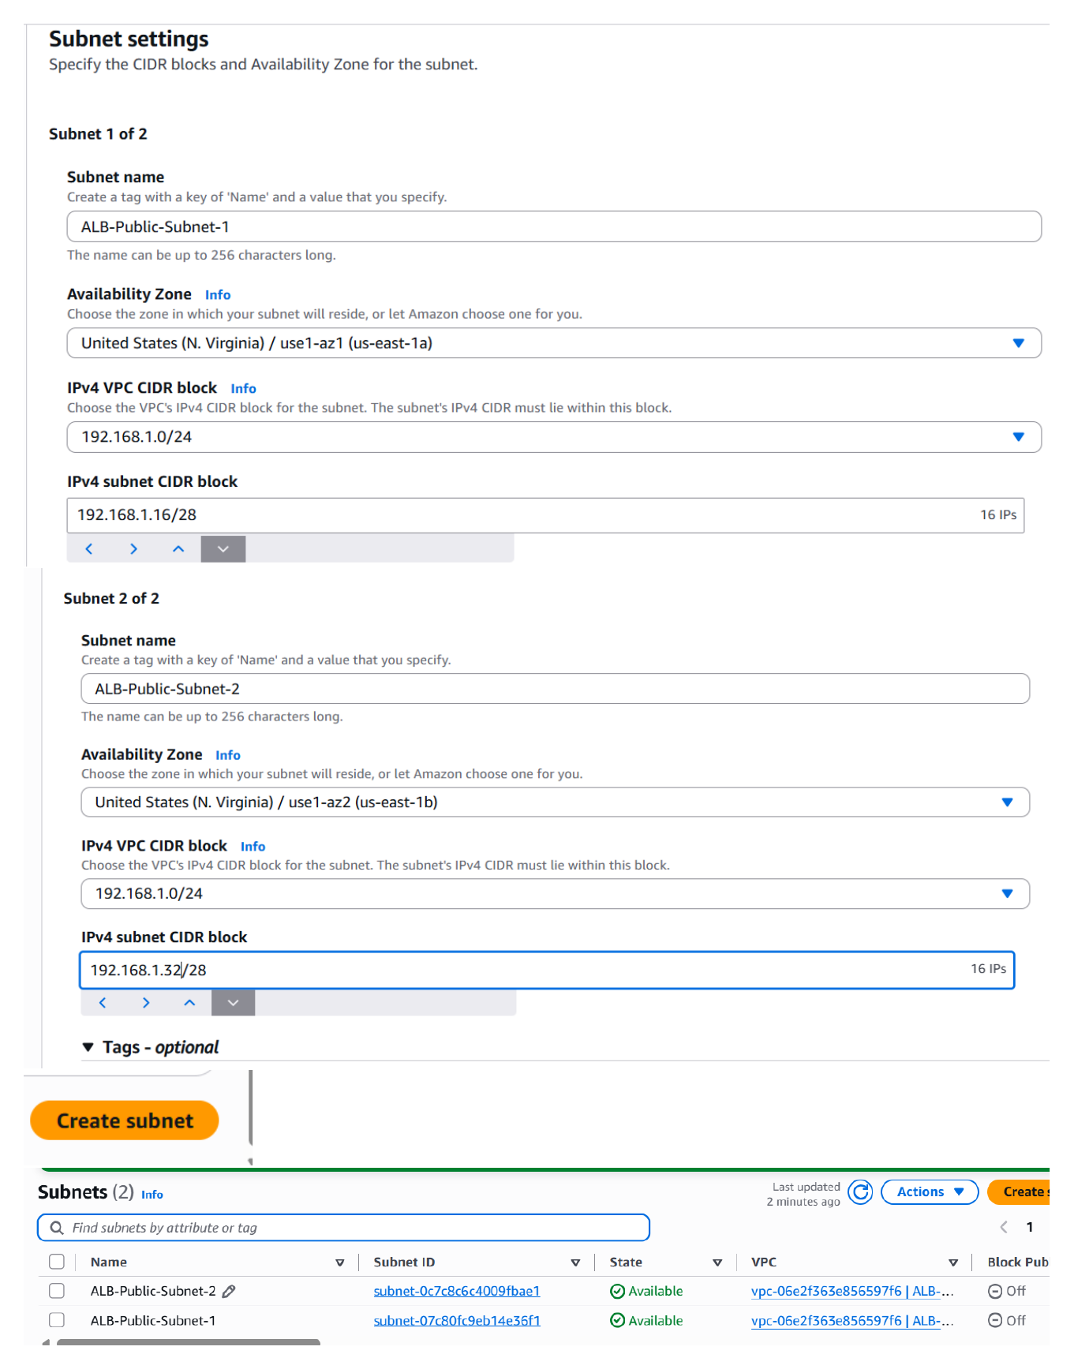
Action: Configured two subnets under the new VPC, including their subnet names, Availability Zone selections, and CIDR ranges for the application servers and load balancer.

Create Internet Gateway and Route Table
Topic: Internet connectivity and routing
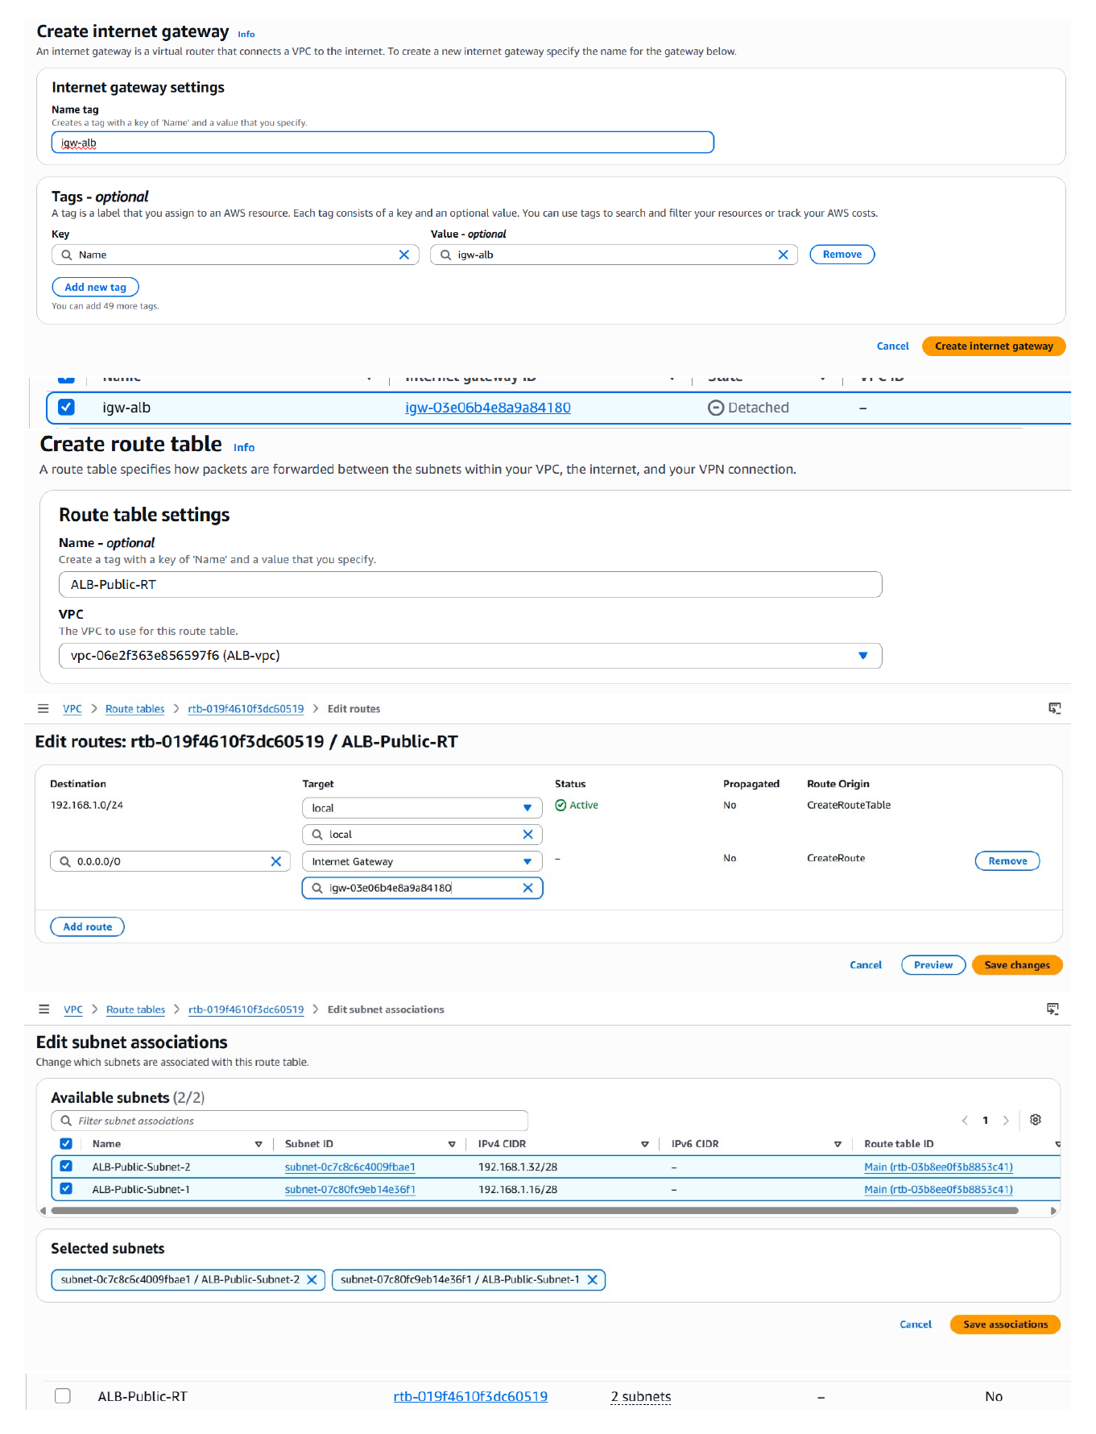
Action: Created an Internet Gateway, associated it with the VPC, and created a route table so the public subnets can use the VPC's internet path.

Enable Auto-Assign Public IP
Topic: Public subnet IP configuration
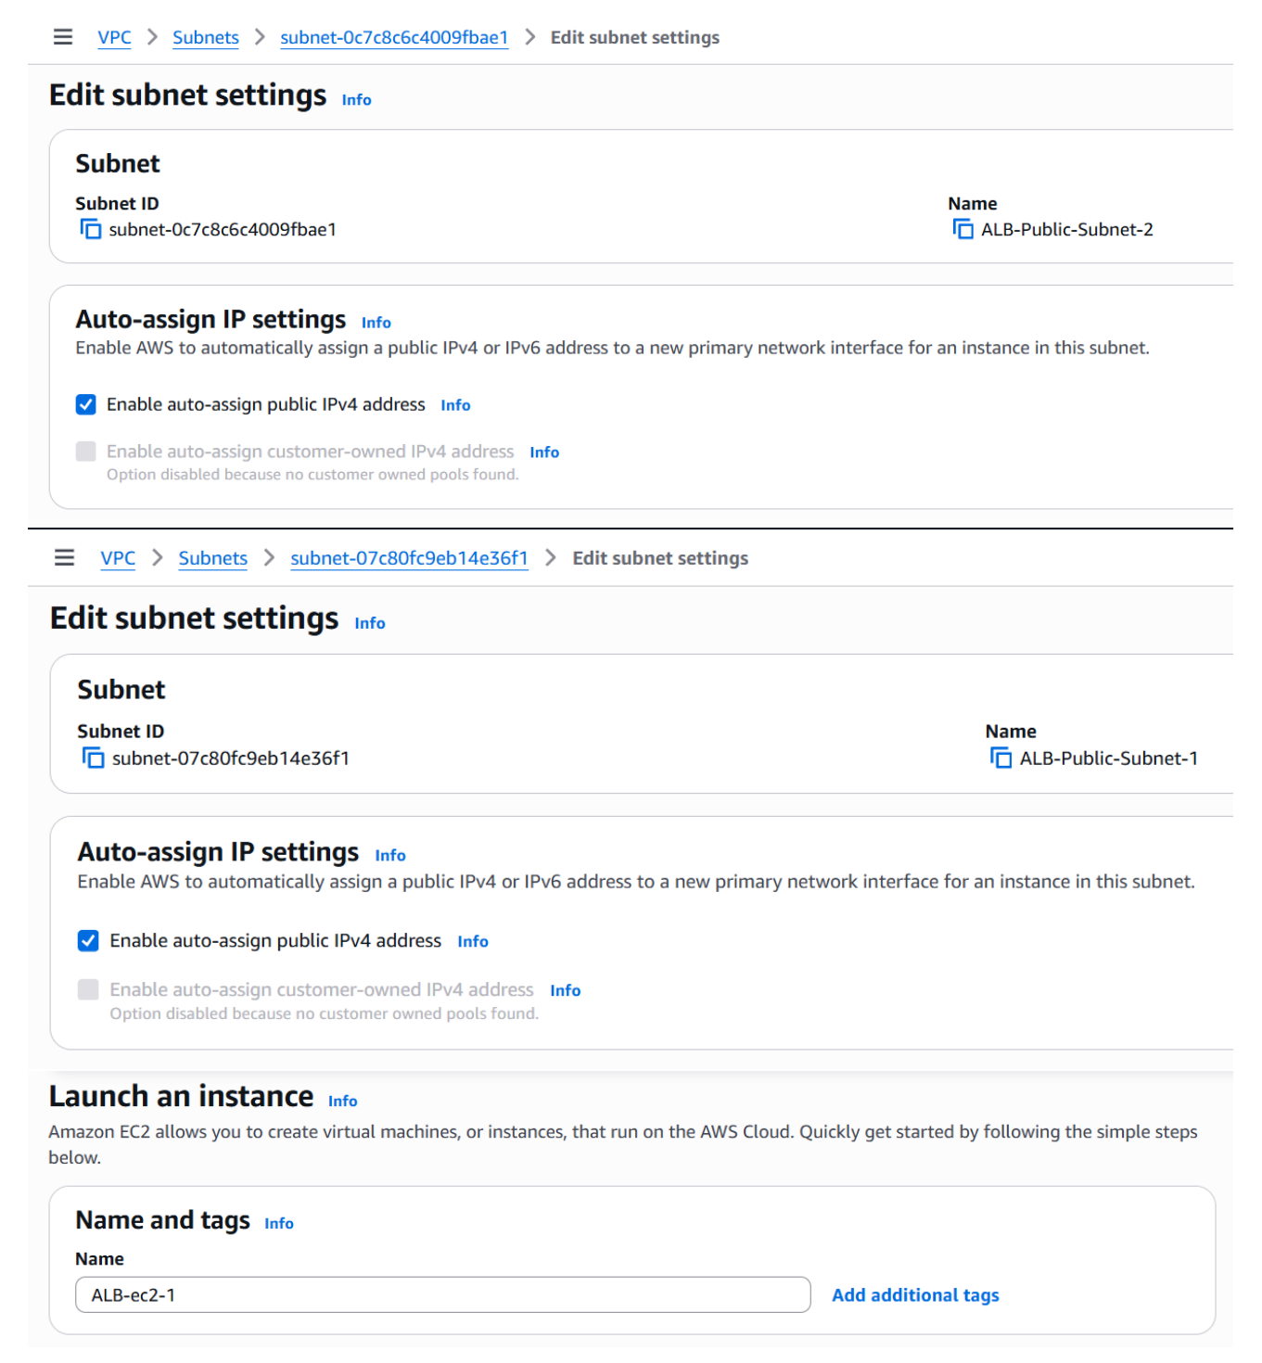
Action: Edited the subnet settings and enabled automatic public IPv4 assignment so instances launched in the public subnets can receive public IP addresses.

Select Amazon Linux AMI
Topic: EC2 instance image selection
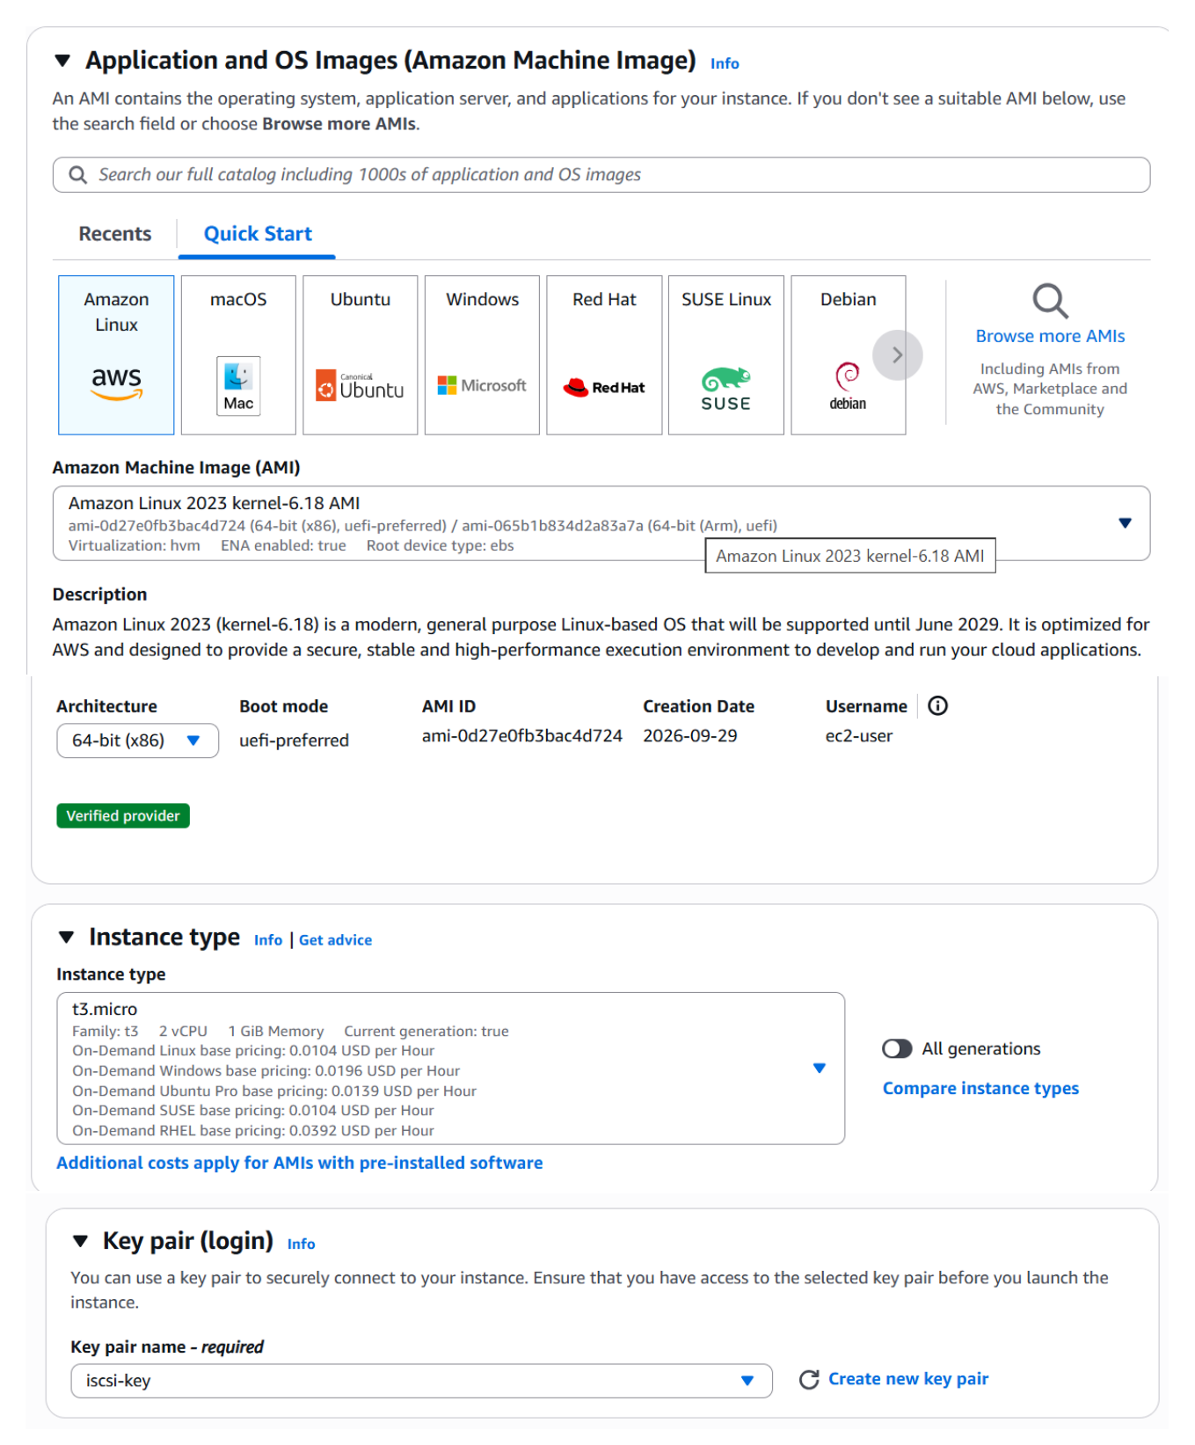
Action: Selected an Amazon Linux 2023 AMI as the operating-system image for the EC2 web-server instances.

Configure EC2 Network Settings
Topic: EC2 VPC, subnet and security configuration
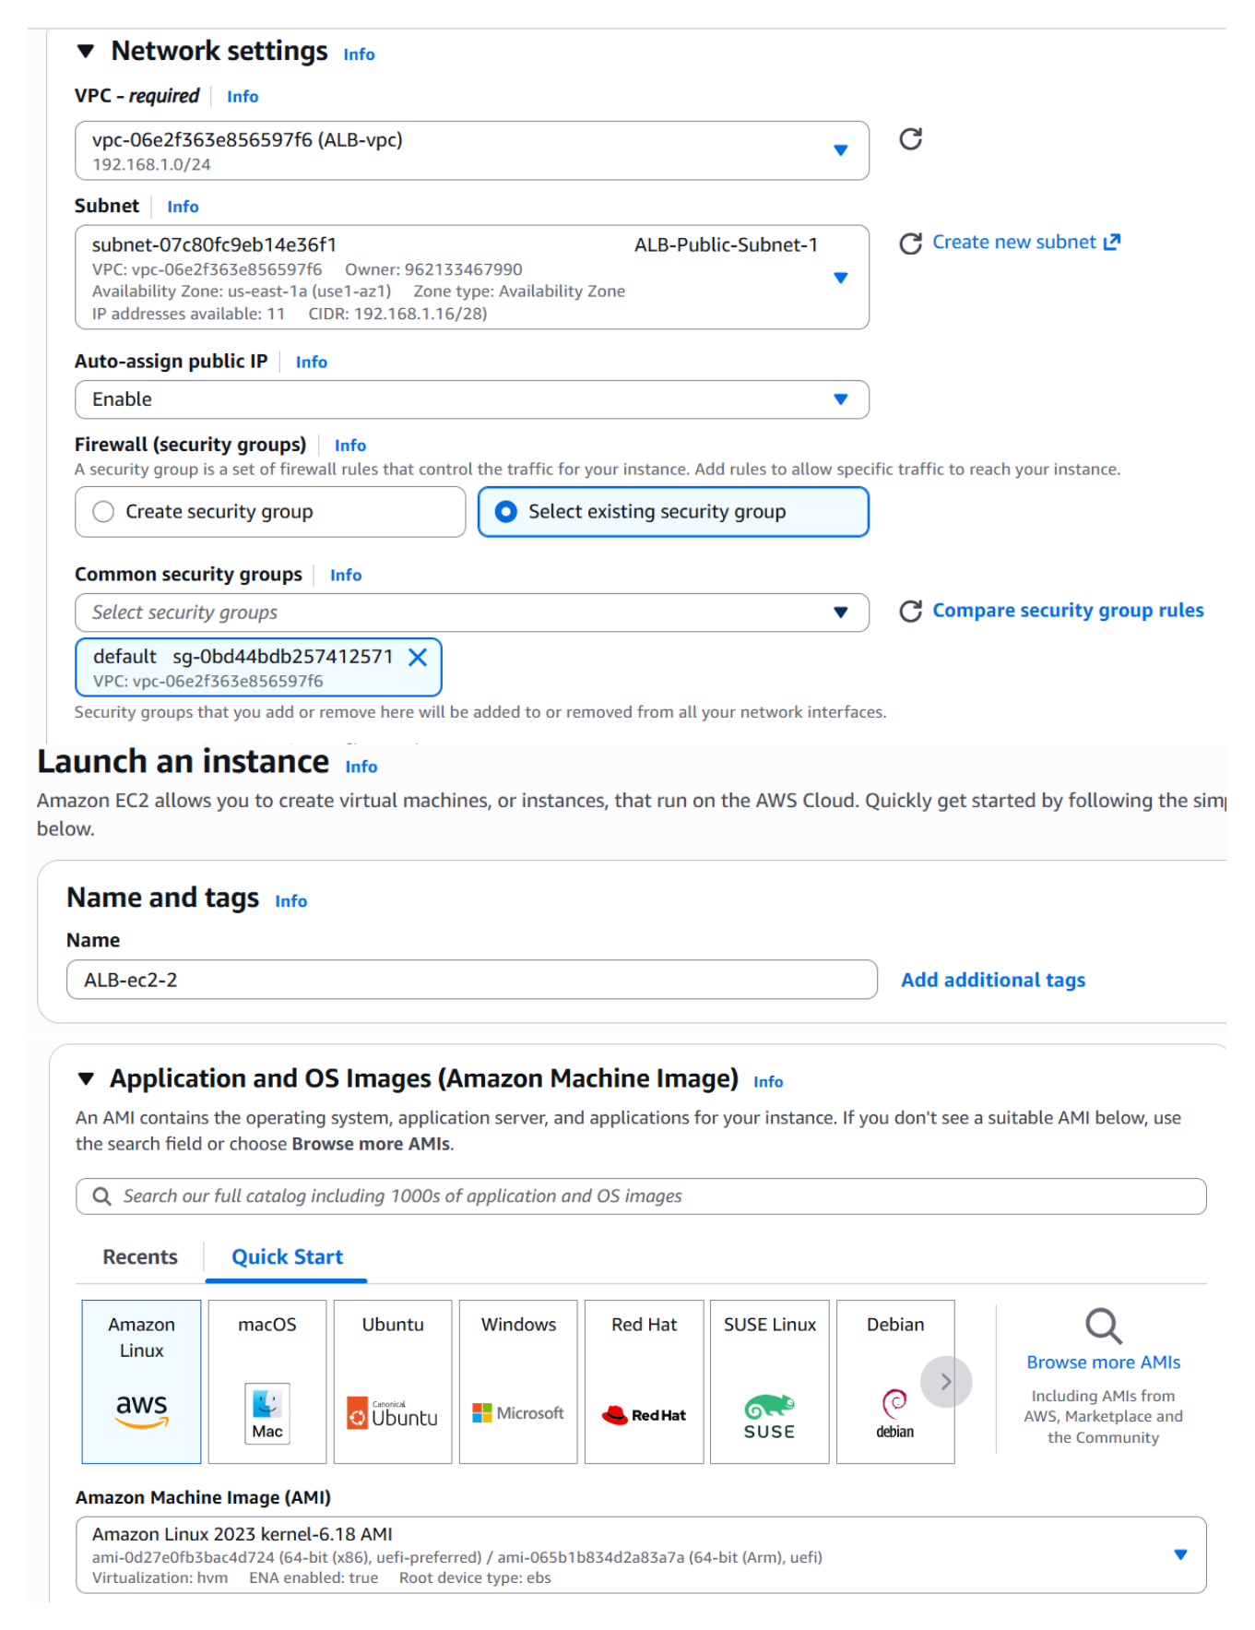
Action: Configured the EC2 launch networking with the created VPC and public subnet, enabled public-IP assignment, and selected the security-group configuration for the instance.

Configure Instance Type and Key Pair
Topic: EC2 instance access settings
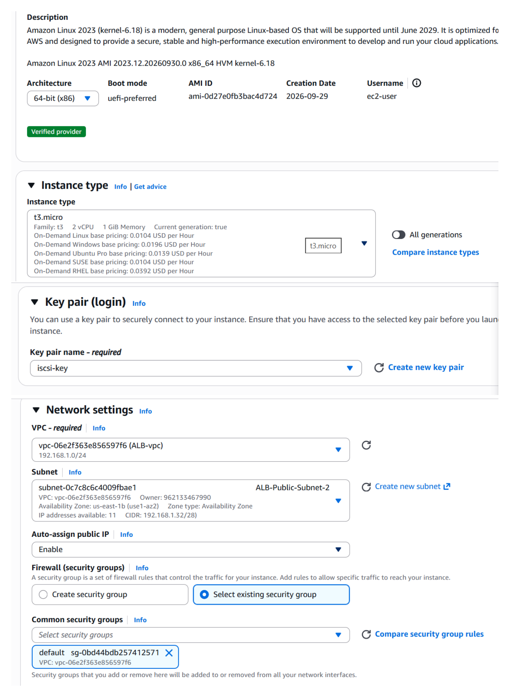
Action: Selected the EC2 instance type and configured the key-pair/login section required to access the instance after launch.

Configure Inbound Rules and Launch
Topic: EC2 access and launch configuration
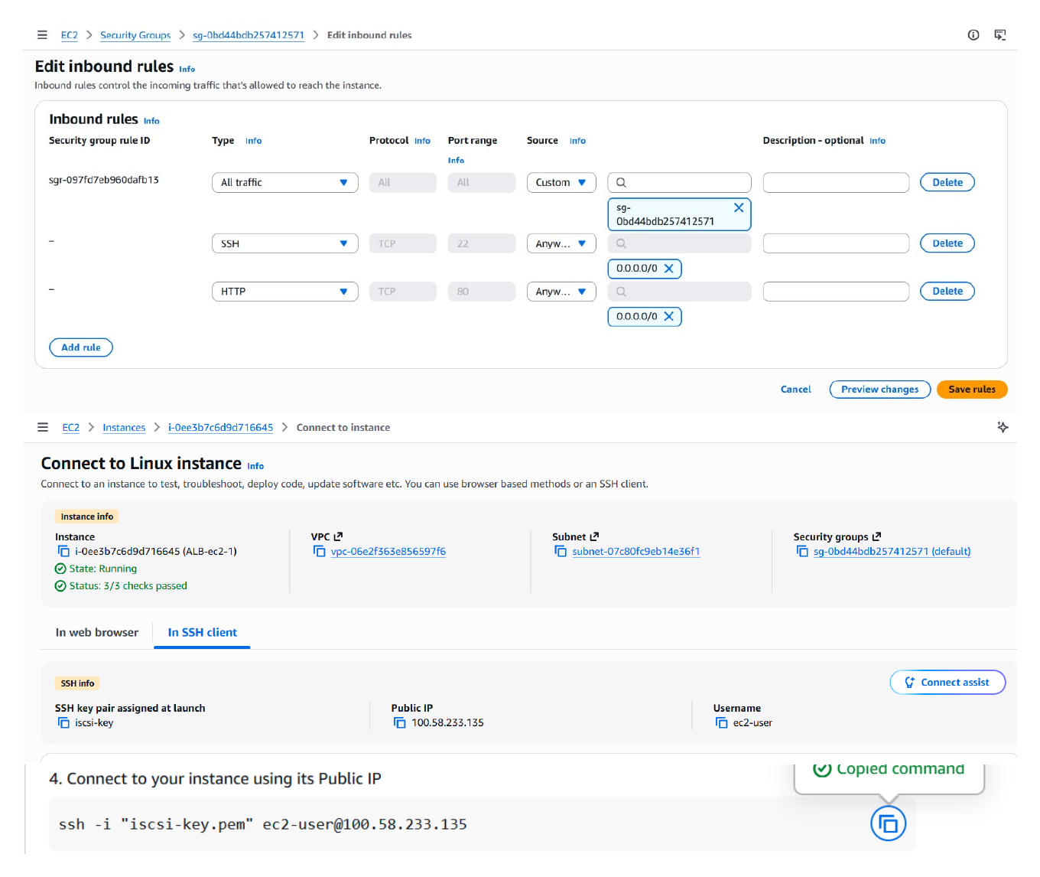
Action: Configured the instance networking and inbound access rules, then proceeded with launching the EC2 instance in the newly created VPC environment.

Install Apache HTTP Server
Topic: Apache/httpd installation
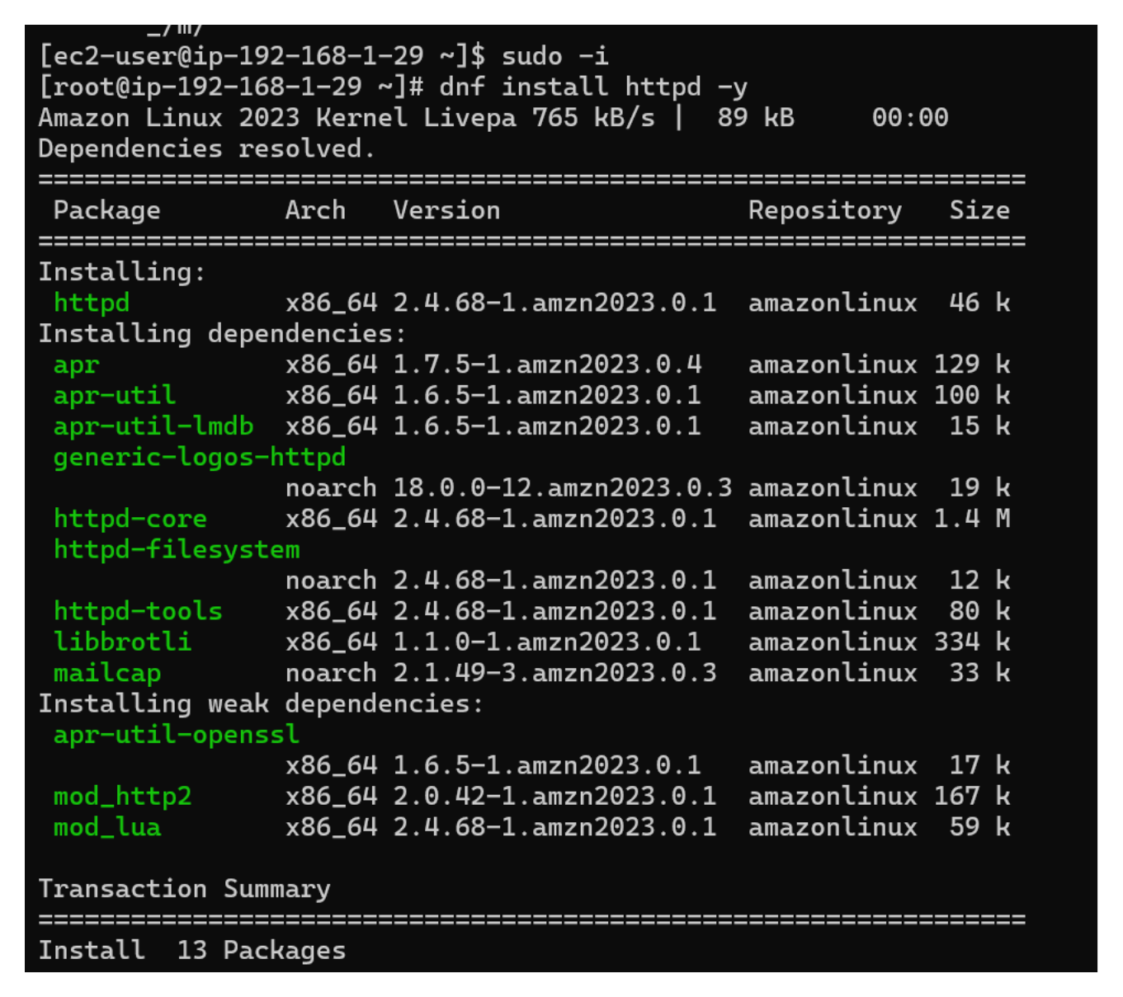
Action: Connected to the Amazon Linux instance and installed the Apache HTTP server package with its required dependencies using the package manager.

Start and Enable Apache
Topic: Apache service management
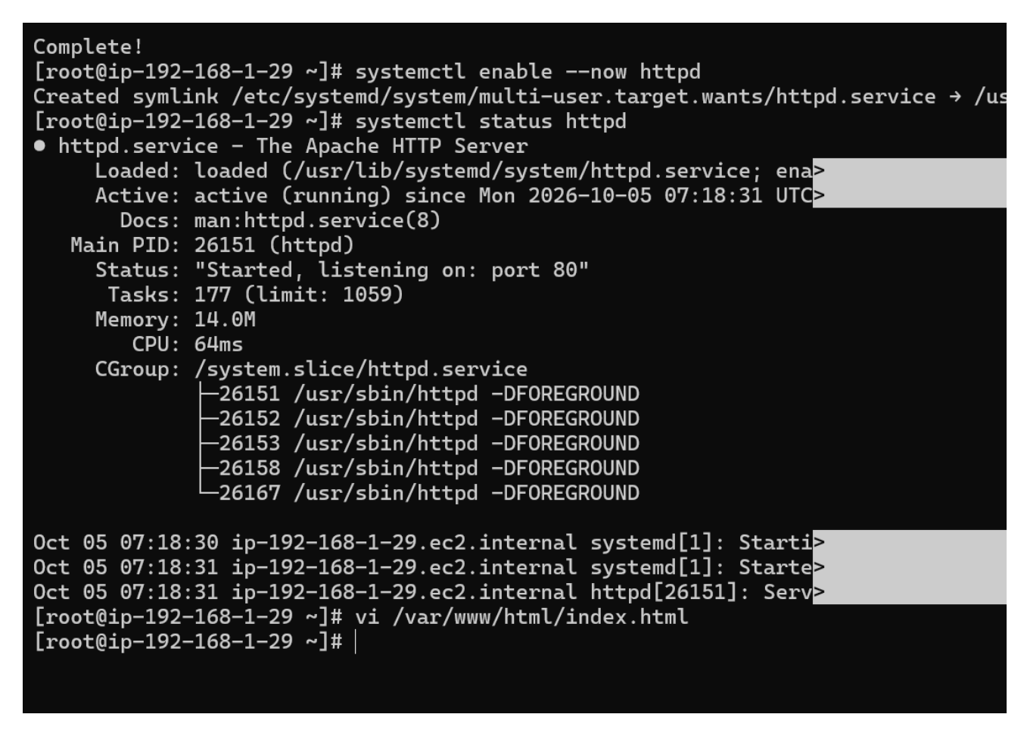
Action: Started the httpd service, enabled it to start automatically, and checked the service status to confirm Apache was running and listening for web traffic.

Create the Suxam Nazar Web Page
Topic: Custom HTML website on the first server
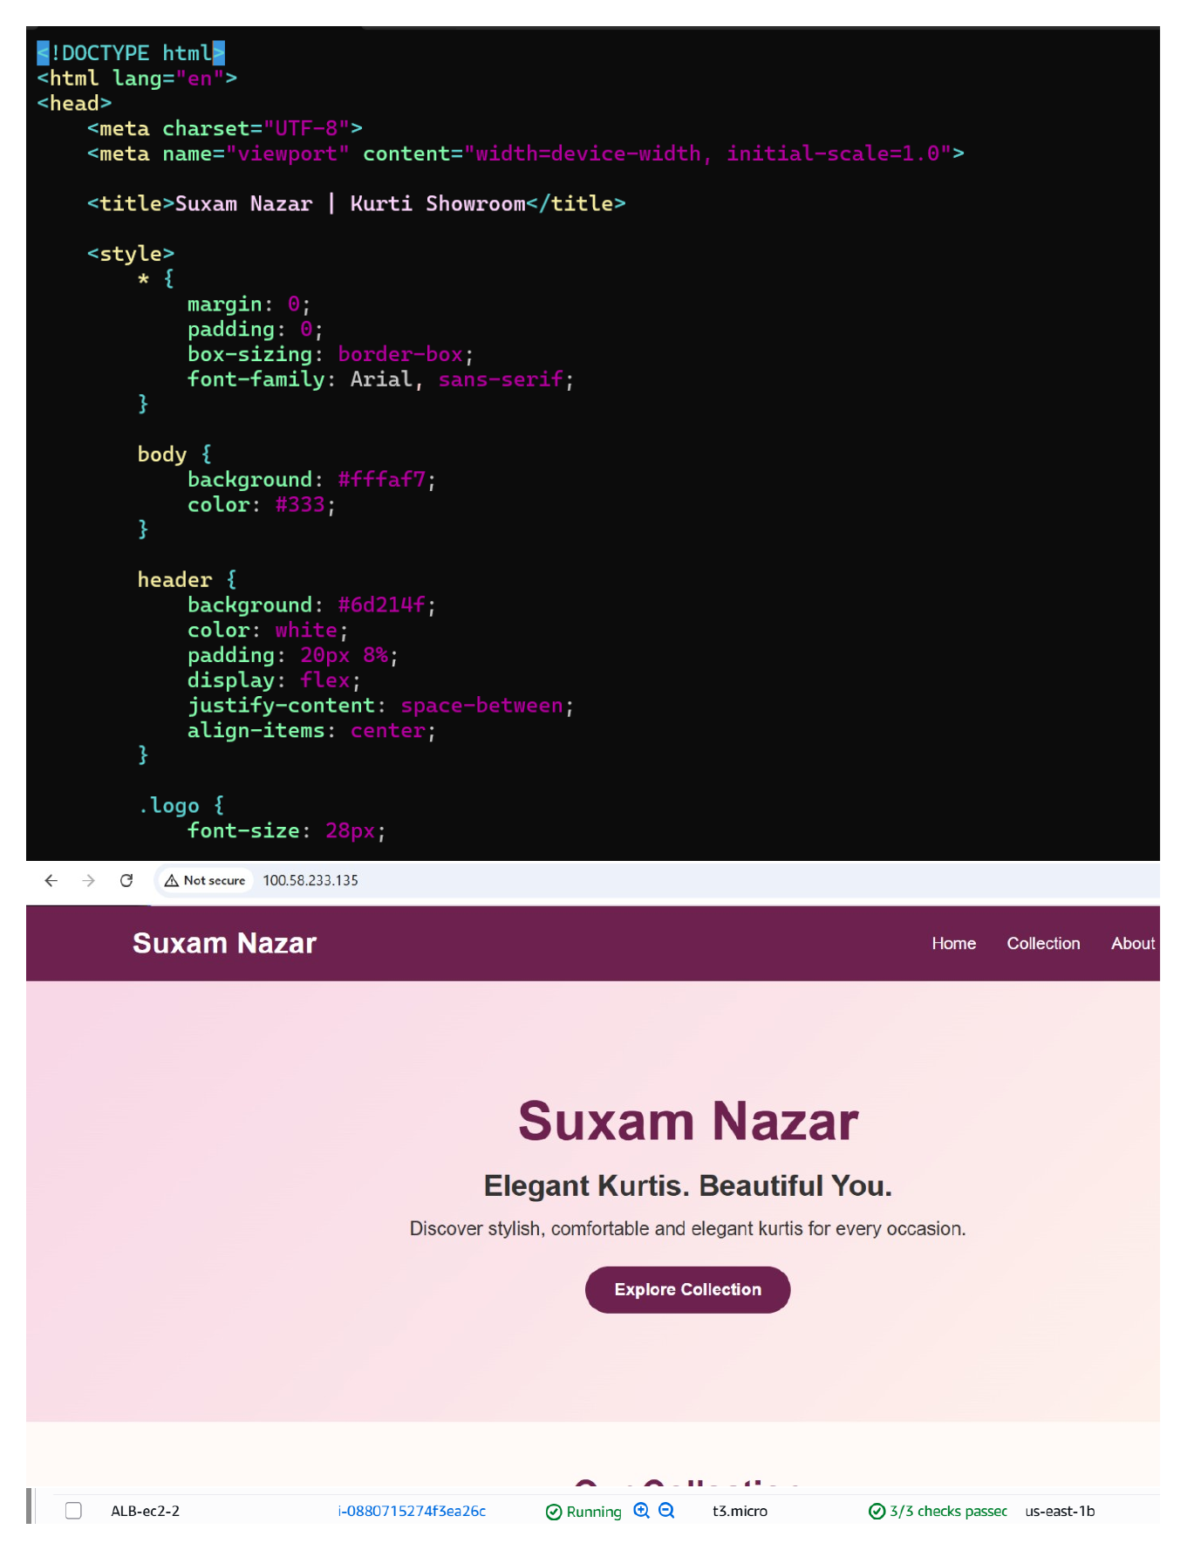
Action: Created and edited the HTML content for the first web server, producing the 'Suxam Nazar' themed page with its custom heading, styling, and collection section.

Configure the Second Web Server
Topic: Apache setup on the second EC2 instance
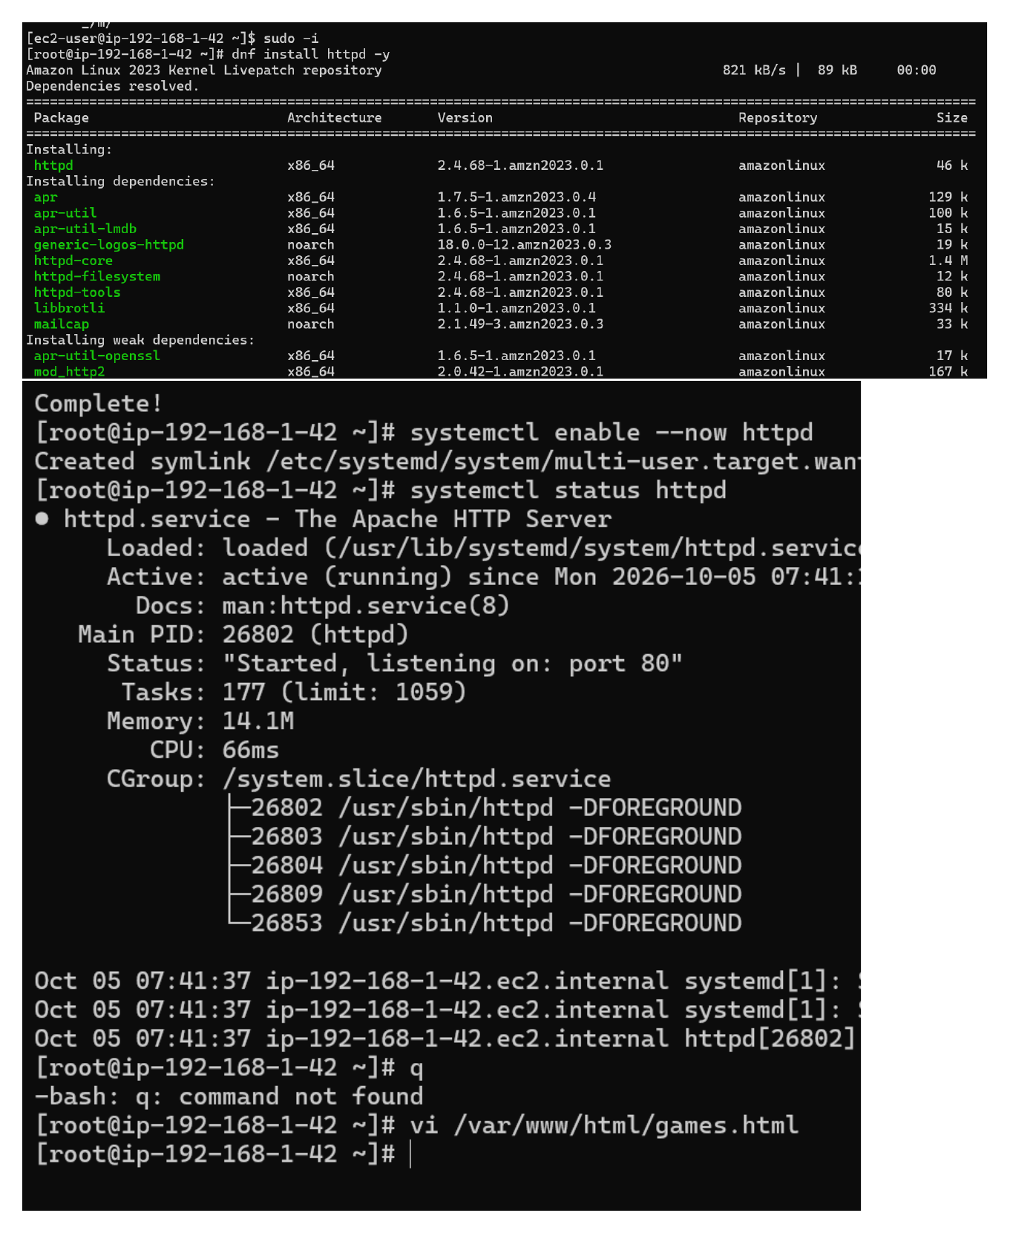
Action: Installed Apache on the second EC2 instance and started/enabled the httpd service so the second server could host its own website.

Create the Nexora Games Web Page
Topic: Custom HTML website on the second server
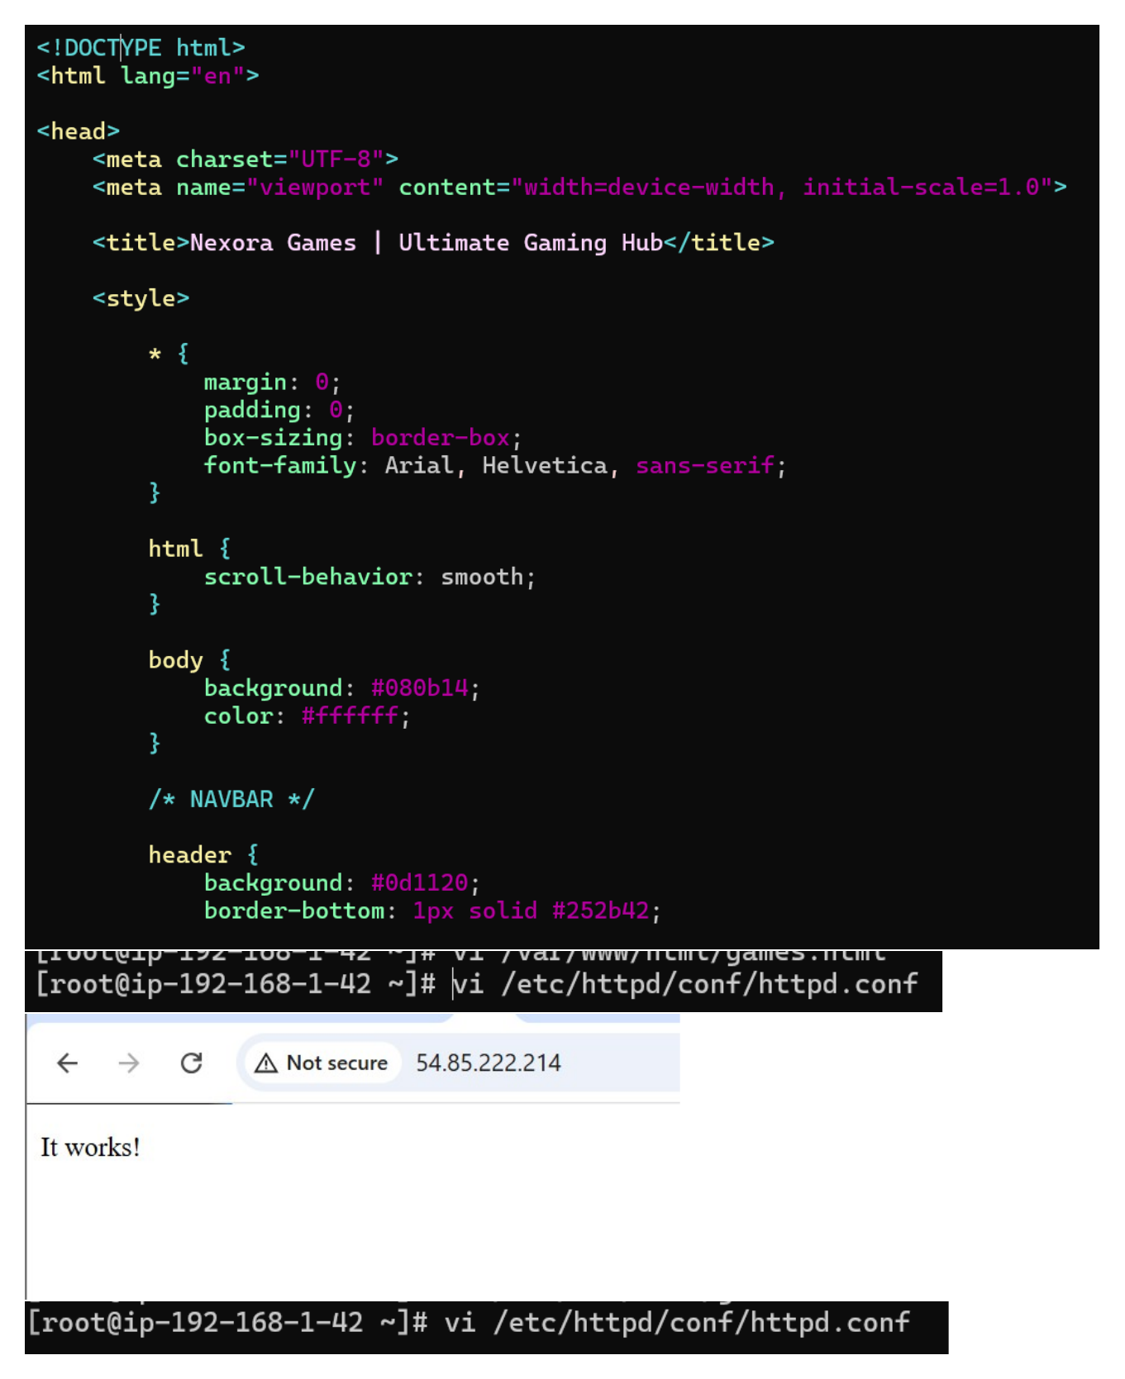
Action: Created the HTML for the second web server and configured the 'Nexora Games' gaming-themed page with its custom layout and content.

Verify the Nexora Games Site
Topic: Browser verification of the web server
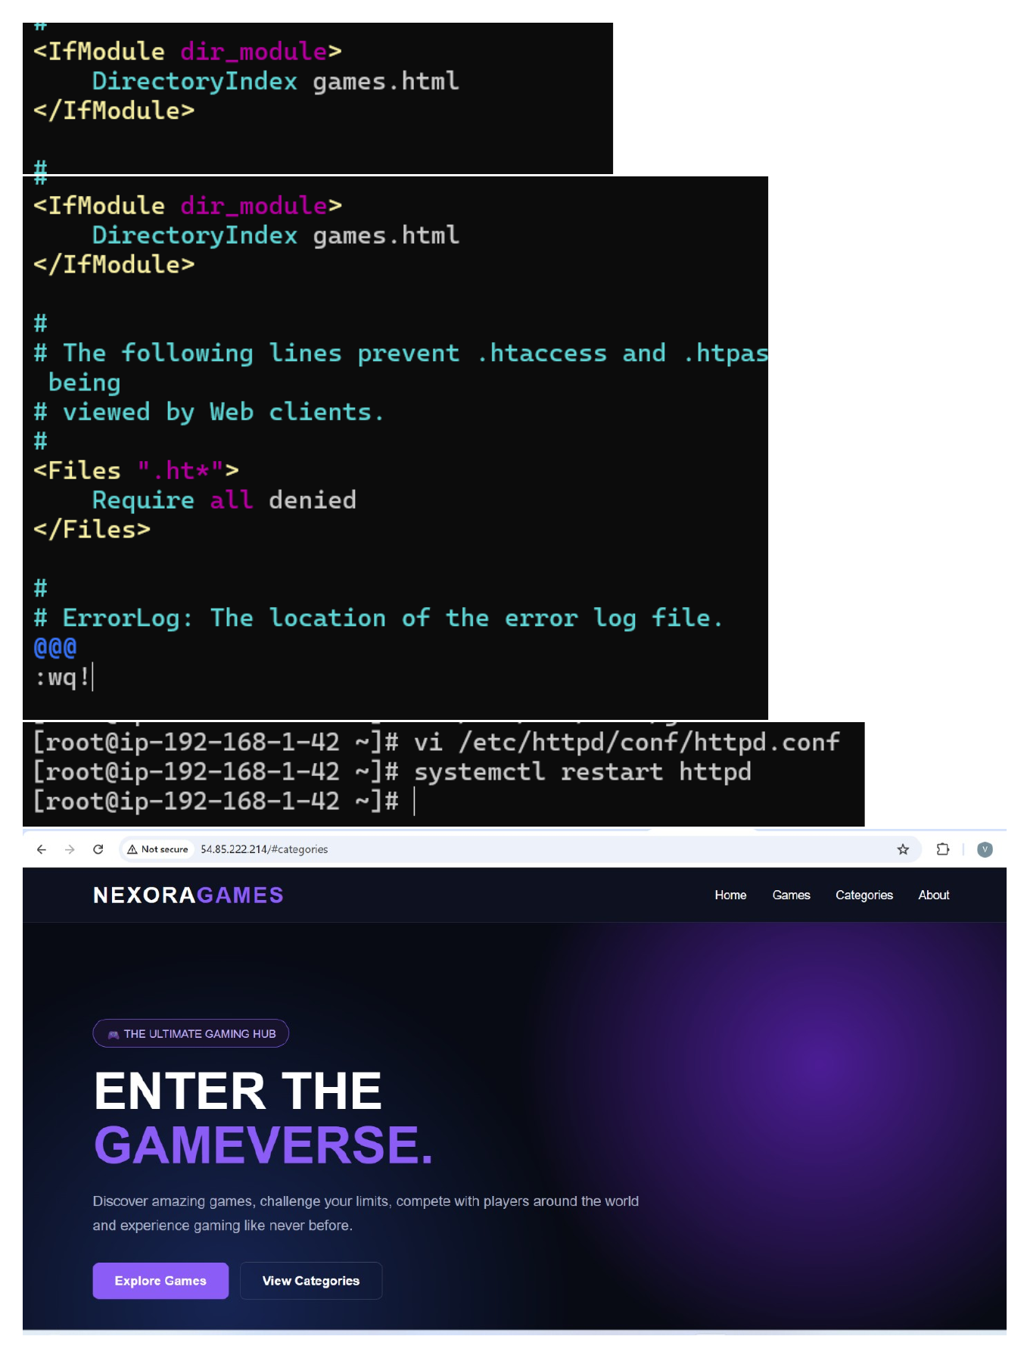
Action: Opened the web server in a browser and verified that the Nexora Games page was being served successfully from the EC2-hosted Apache server.

Create Load Balancer Security Group
Topic: Security group for the Application Load Balancer
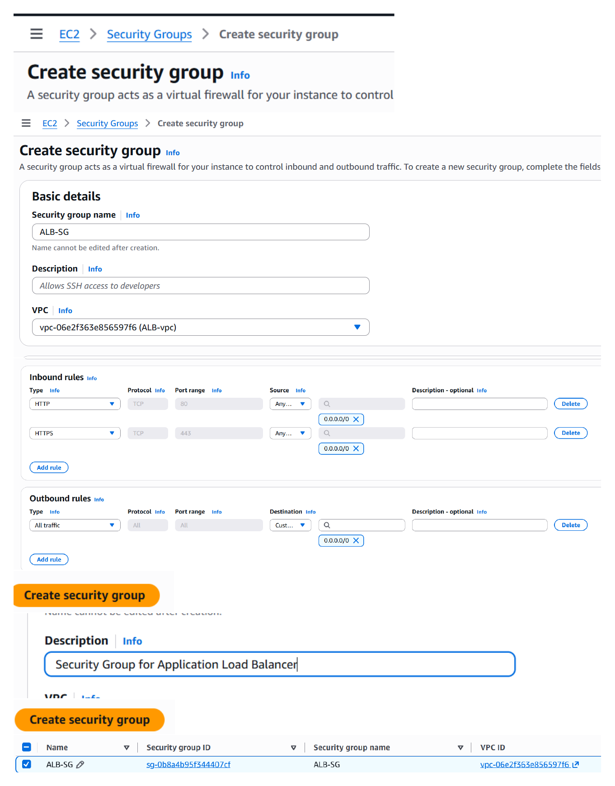
Action: Created a dedicated security group for the Application Load Balancer and configured its inbound access settings for web traffic.

Create Target Group
Topic: ALB target-group configuration
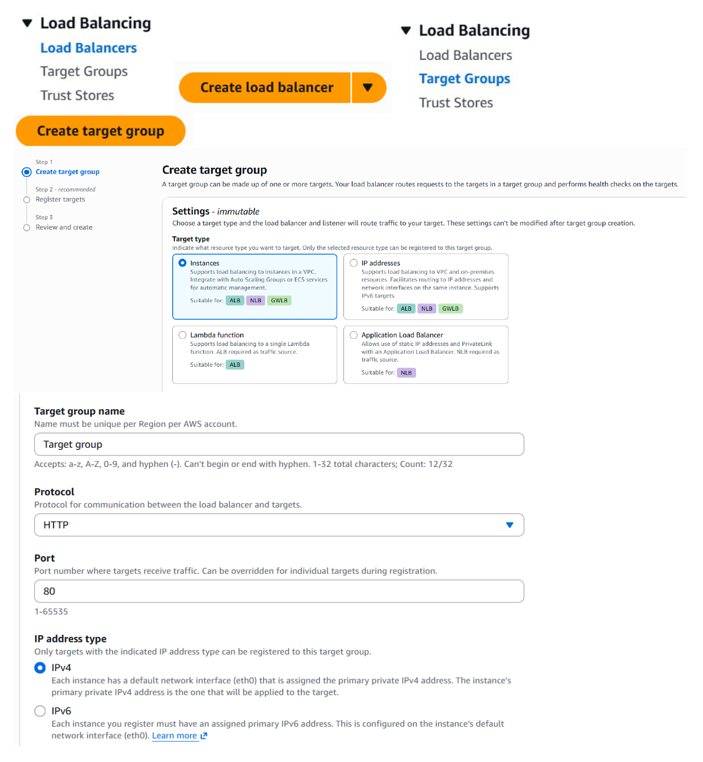
Action: Started creating the target group that will receive HTTP traffic from the Application Load Balancer and route requests to the EC2 instances.

Configure Target Health Checks
Topic: Target-group health monitoring
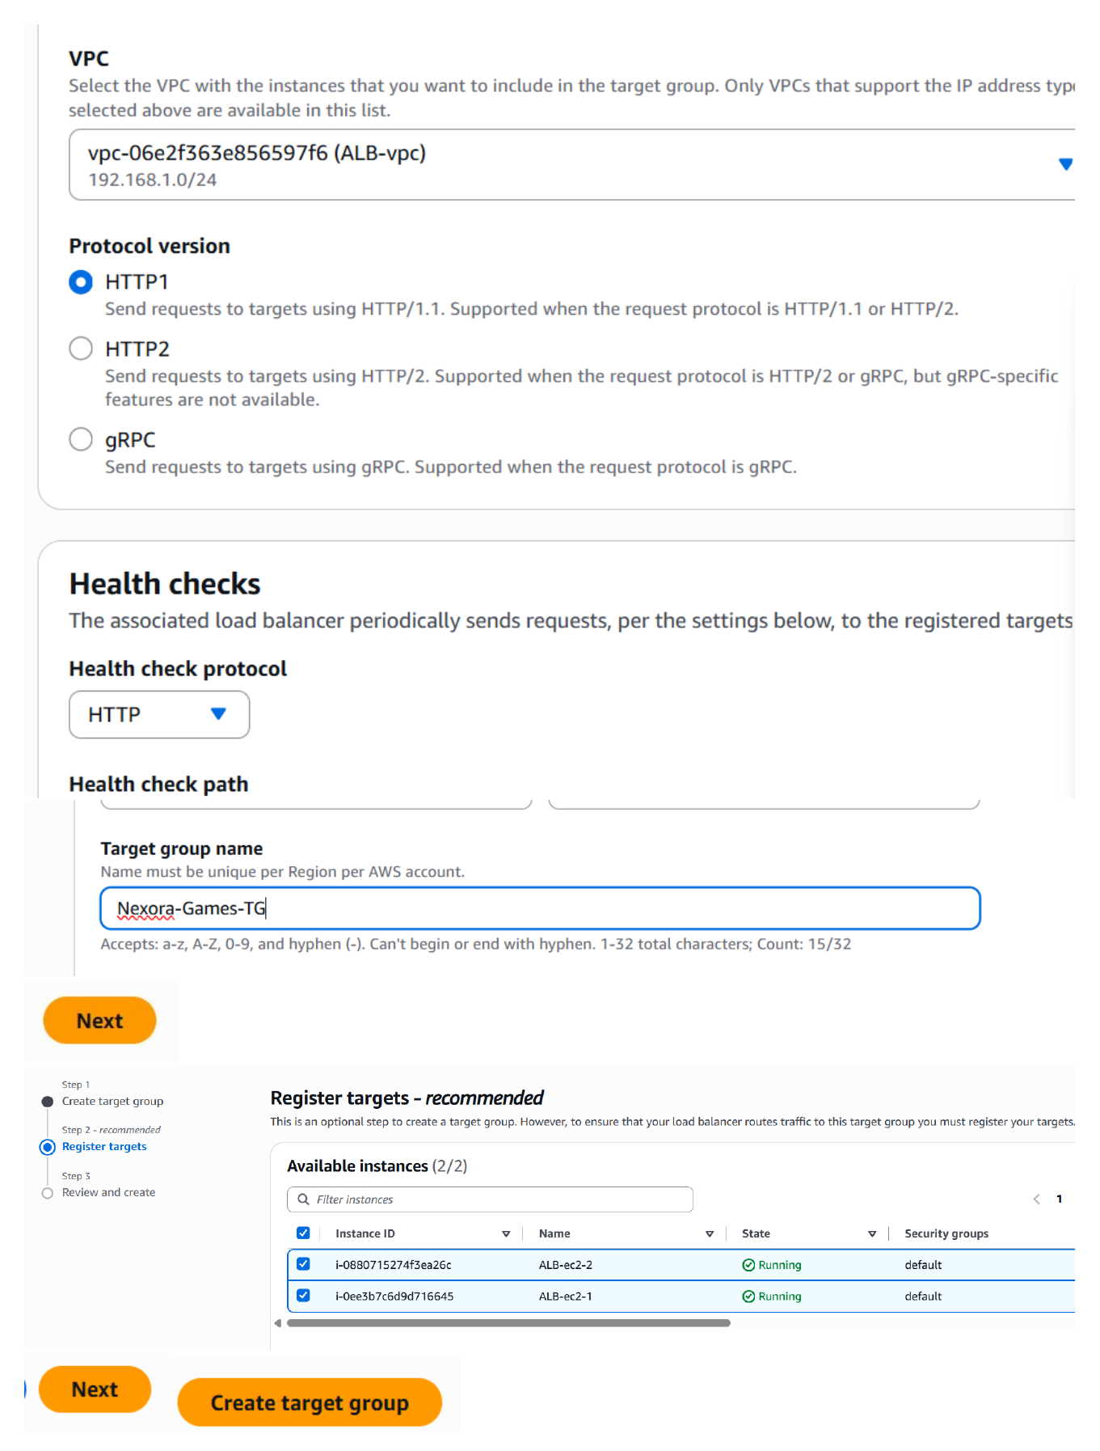
Action: Configured the target group to use HTTP health checks and specified the health-check settings used to determine whether registered EC2 targets are healthy.

Create the Application Load Balancer
Topic: ALB basic configuration
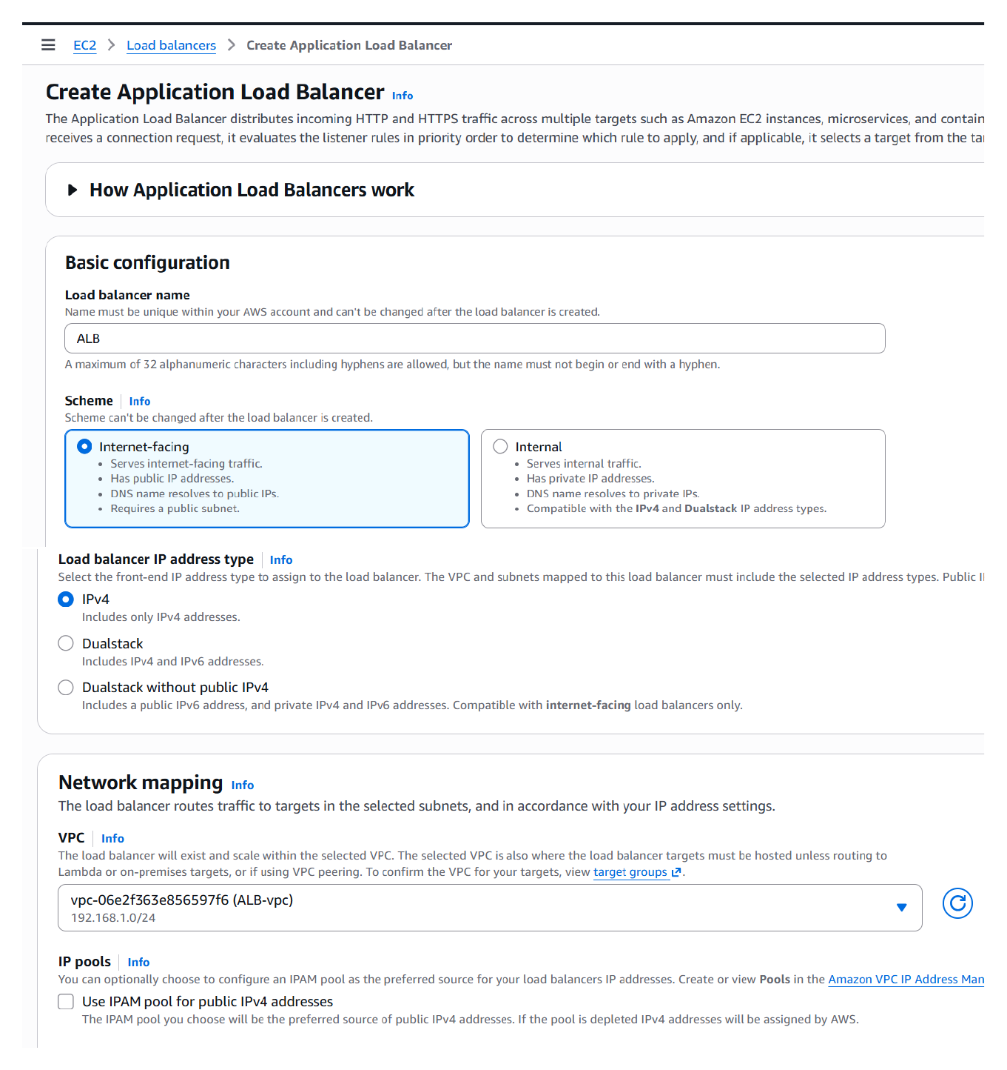
Action: Created an internet-facing Application Load Balancer, selected the load-balancer scheme and IP configuration, and began the listener/network setup.

Select Availability Zones and Security Group
Topic: ALB networking configuration
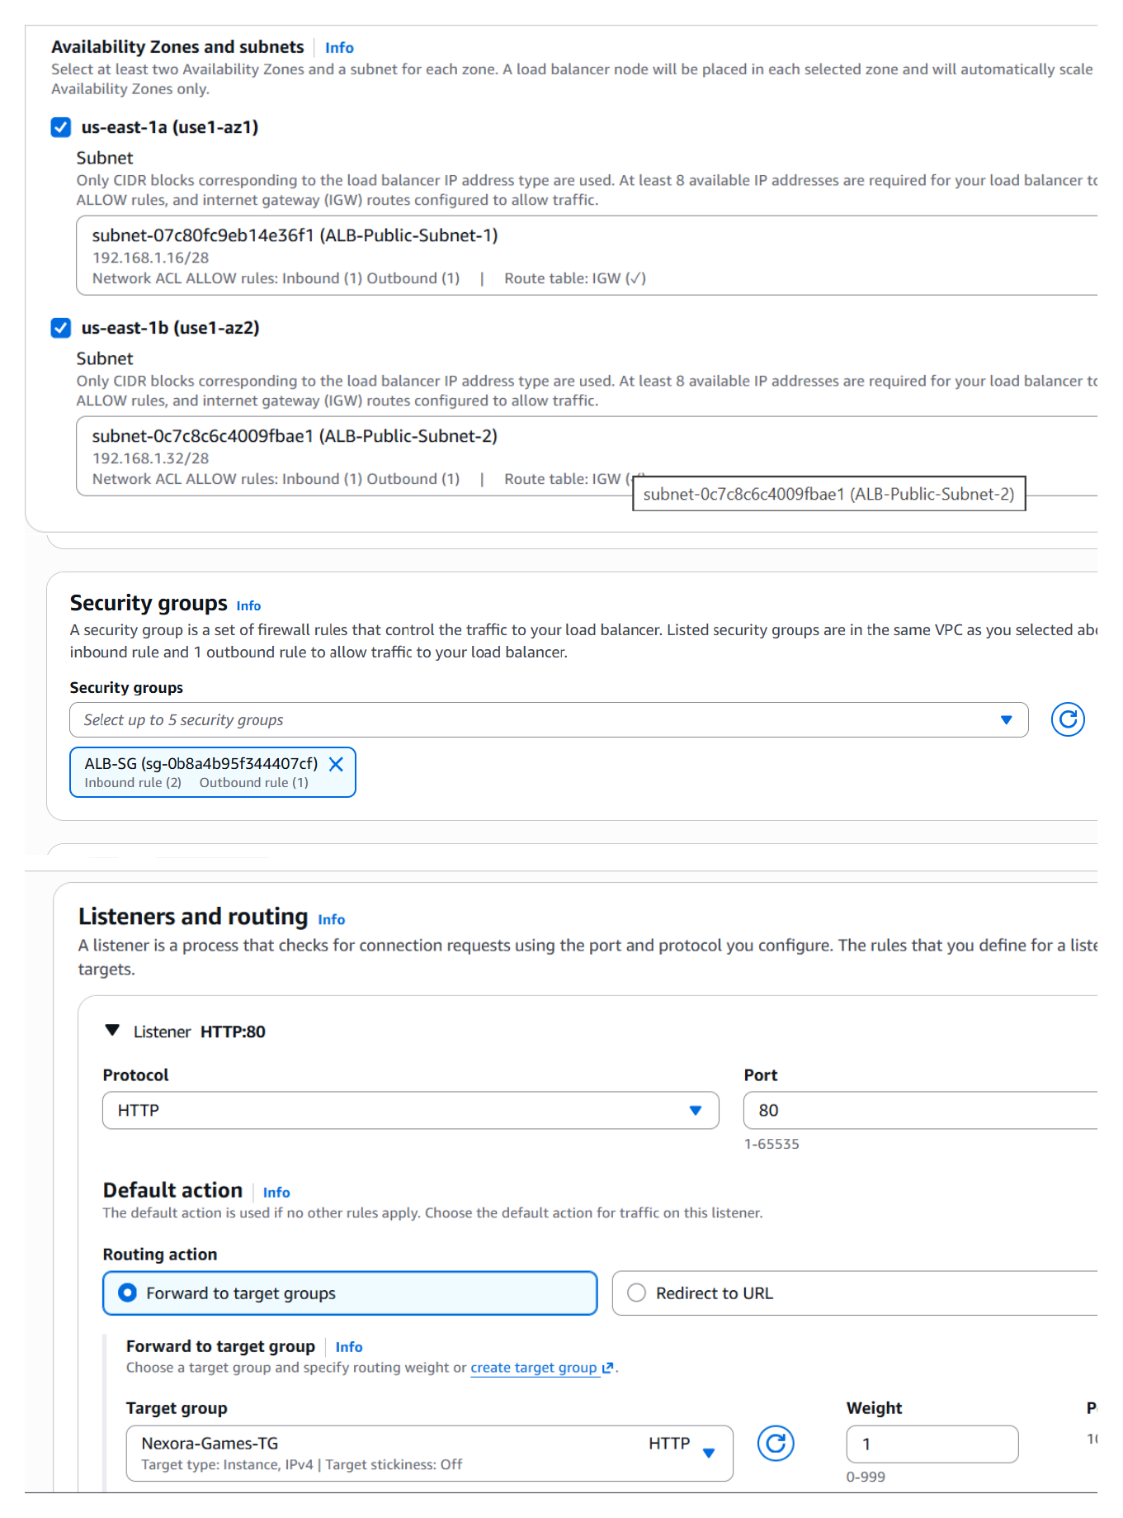
Action: Selected the VPC Availability Zones/subnets for the load balancer and attached the load-balancer security group to control incoming web traffic.

Register EC2 Targets
Topic: Register web servers with the target group
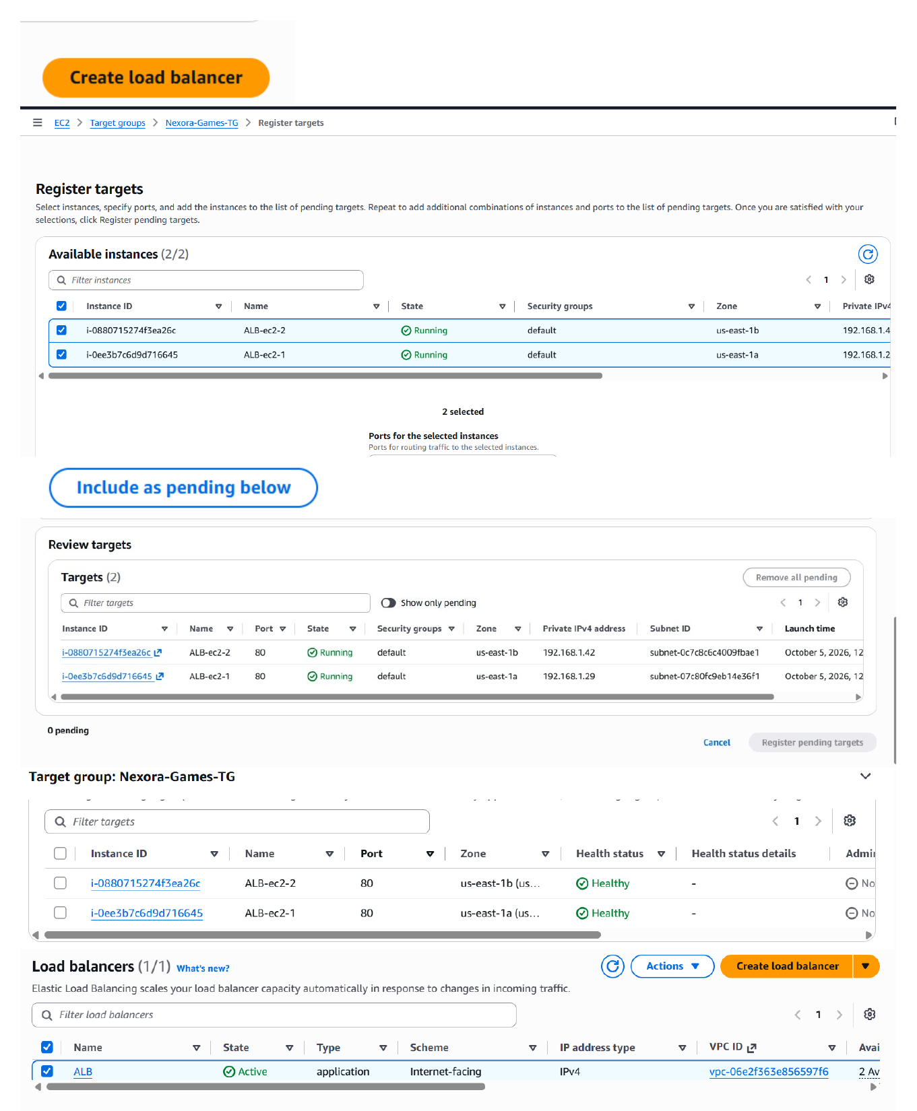
Action: Registered the EC2 instances as targets of the target group and confirmed the selected instances were included before completing the load-balancer setup.

Verify Load Balancer and Target Health
Topic: ALB status and target registration
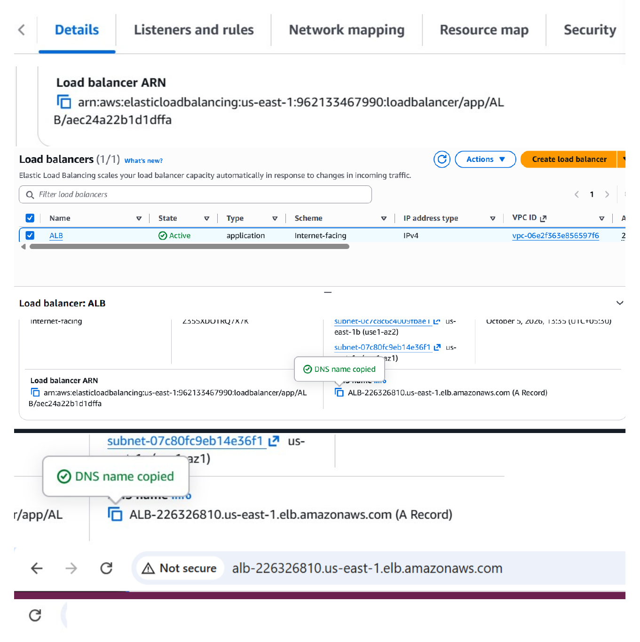
Action: Checked the Application Load Balancer details and target information to verify that the load balancer and its registered EC2 targets were available.

Open the ALB DNS Name
Topic: Load-balanced Nexora Games website
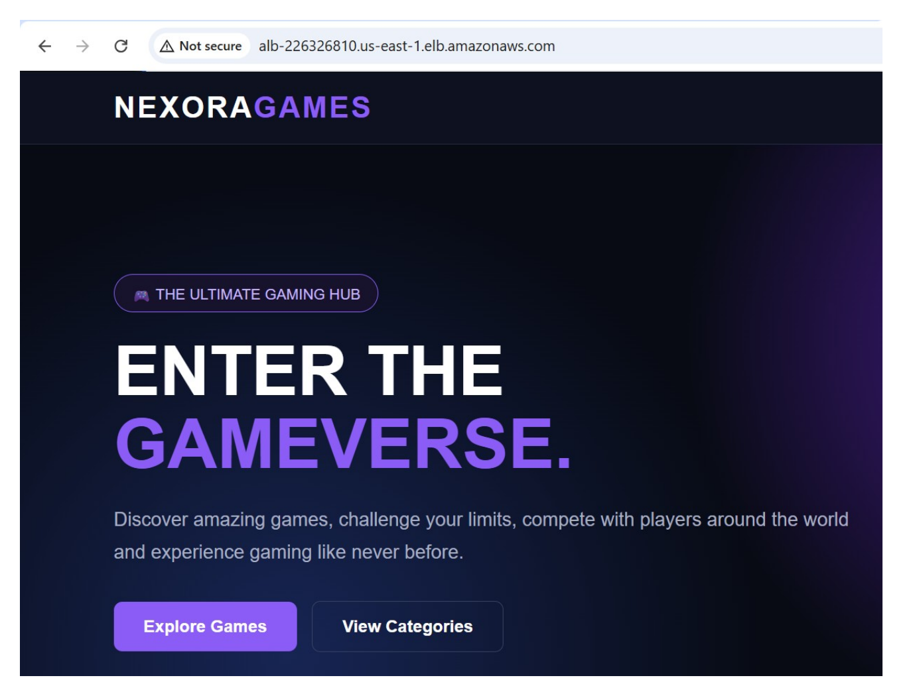
Action: Opened the Application Load Balancer's DNS endpoint in the browser and verified that the Nexora Games website was reachable through the load balancer.

Verify the Second Website
Topic: Web-server content verification
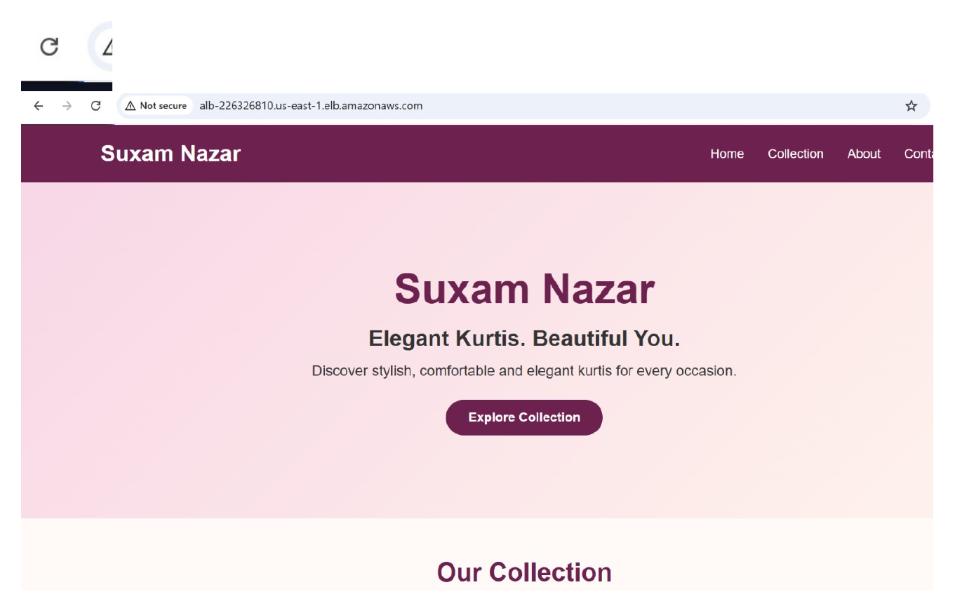
Action: Opened the other hosted website in the browser and verified the Suxam Nazar page, confirming the second web-server content was available.

